Erik Barmack
CEO, Wild Sheep Content
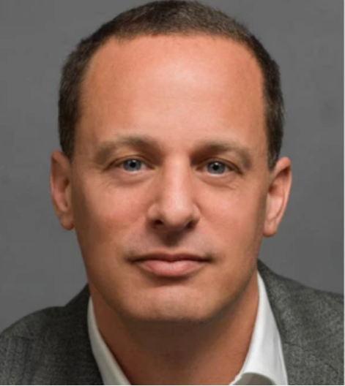
Details to follow

John Wirth
Showrunner / Executive Producer

John Wirth has written and produced hundreds of hours of television and continues to be one of Hollywood’s most sought-after television Showrunners. He is currently serving as Executive Producer/Showrunner on the Netflix original series Wu Assassins, which he created. He has served as Executive Producer/Showrunner on Hap And Leonard (SundanceTV); Hell On Wheels (AMC); The Cape (NBC); Terminator: The Sarah Connor Chronicles (FOX); Love Monkey; Ghost Whisperer; The District and Nash Bridges (CBS).

He’s worked as a Consulting Producer on Falling Skies (TNT) and V (ABC), and as a Supervising Producer on the award-winning Picket Fences (CBS) and the cult favorite The Adventures of Brisco County, Jr. (FOX). He also worked as an Executive Story Editor on Remington Steele (NBC).

Mr. Wirth has held development deals with AMC, A&E, CBS, NBC, Touchstone Television, 20th Century Fox Television, Sony Television, Grant Tinker Television, and Warner Brothers Television, producing pilots for all four major networks, USA, CW and A&E. He conceived and co-edited the WGA’s TELEVISION WRITER’S HANDBOOK and sits on the Showrunner Training Program Committee as well as the WGA’s Television Writers Council.

Mr. Wirth has been honored with multiple award nominations, most recently a Banff World Media Festival Rockie Award for Best Sci-fi/genre show for Wu Assassins. He won three Western Heritage Awards for Hell On Wheels, an Environmental Media Award, an Angel Award, and the 2004 Ribbon of Hope Award for AIDS Awareness and Education for The District.

Liz Craft & Sarah Fain
Showrunners / Executive Producers

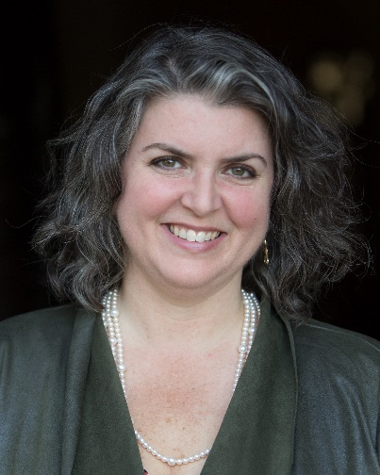
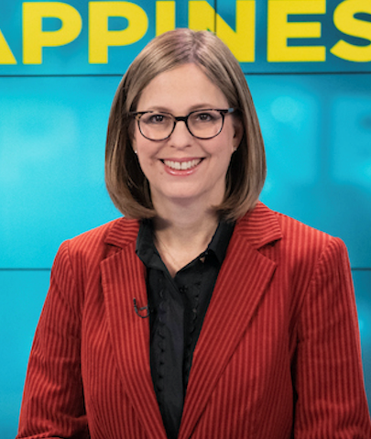
Liz Craft & Sarah Fain wrote their first piece together when they were fifteen — an article on Kansas City delis for their high school newspaper. Liz attended Columbia University in New York and went on to work as an editor of young adult books. Sarah attended Williams College then joined Teach For America, where she taught high school English and Creative Writing in rural North Carolina.
After a night of beer drinking during a visit home, Liz and Sarah decided to move to L.A. and write for television. Since then they have Executive Produced, created, and written for numerous television shows including Joss Whedon’s Angel, the Emmy Award-winning show The Shield, Women’s Murder Club (which they created based on the James Patterson novels), The Vampire Diaries, and Lie To Me. Most recently, Liz and Sarah created the ABC show The Fix with former Los Angeles prosecutor Marcia Clark. They’ve co-written two Young Adult novels, Bass Ackwards & Belly Up and Footfree & Fancyloose.
Liz and Sarah co-host the hugely popular weekly podcast Happier In Hollywood, which is about how to survive the war of attrition that is life in Los Angeles. It was recognized in Apple’s New & Noteworthy and has over five million downloads. They are represented by manager Dianne Fraser (Industry Entertainment) and attorney Patti Felker (Felker Toczek Suddleson Abramson LLP).

Mark Goffman
Showrunner / Executive Producer

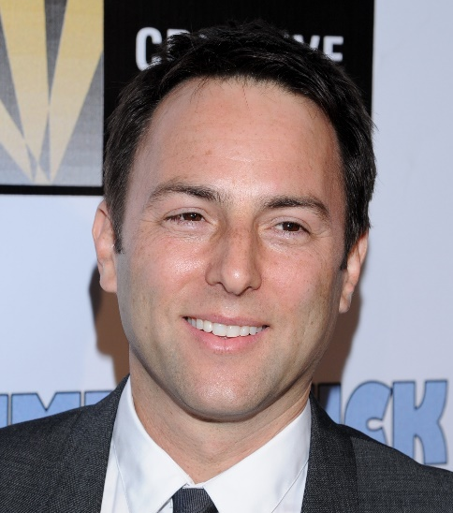
Mark Goffman is an executive producer for the Netflix series, THE UMBRELLA ACADEMY. Prior to that, Goffman executive produced and was the showrunner for BULL, on CBS, and also served as an executive producer for LIMITLESS on CBS and USA’s WHITE COLLAR. He was also the showrunner for SLEEPY HOLLOW, on Fox. His pilot VICTOR, starring John Stamos, was produced for NBC. His first staff position was on THE WEST WING, where he wrote for several seasons. Afterwards, Goffman ran the writers' room for Aaron Sorkin's STUDIO 60 ON THE SUNSET STRIP.

Goffman has worked on more than 200 hours of scripted television, been nominated for two Writers Guild Awards and won the Entertainment Industries Council SET Award. The Hollywood Reporter has listed Goffman as one of the 50 most influential writers in television. One of his episodes of LAW & ORDER: SVU garnered Golden Globe and Emmy nominations for Mariska Hargitay.

Goffman's feature directorial debut is DUMBSTRUCK, a documentary about ventriloquists, theatrically released by Magnolia Pictures. He currently has a feature film in development with Grey Matter (LIGHTS OUT, THE LAUNDROMAT).

Goffman began his career as a writer in Brussels, for the magazine Commerce in Belgium. He has a Masters in Public Policy from the Harvard Kennedy School, wrote speeches for state and federally elected officials, consulted to the U.S. military, Department of State and White House.

Goffman has a B.A. from Emory University in Economics and Philosophy and served as a Masters Thesis Adviser, Fiction Writing Program, at Johns Hopkins University. His first play, ME TOO, has run in Los Angeles and Indianapolis.

Jeff Rake
Showrunner / Executive Producer

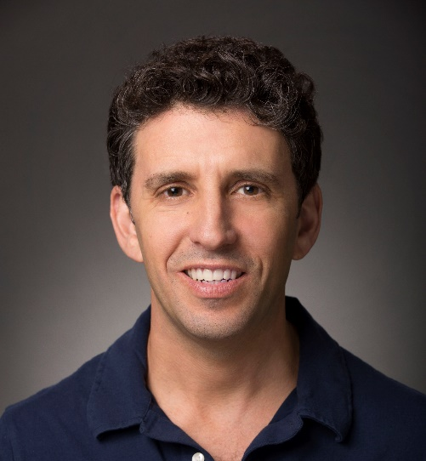
Jeff Rake serves as executive producer, writer, and showrunner for NBC’s “Manifest,” which just finished airing its second season.
After a short career in law, Rake co-created “The $treet” for Fox, “Miss Match” for NBC and also co-wrote the pilot for ABC’s “Boston Legal.”
In 2013, he developed “The Mysteries of Laura,” which aired for two seasons on NBC and in more than 100 countries around the world.
He has written and produced episodes of “The Practice,” “Bones,” “Head Cases,” “Cashmere Mafia,” “Hawthorne,” “Beauty and the Beast” and “The Tomorrow People,” as well as the 1996 Elvis Presley hip-hop musical “Hound Dog: A Hip hOpera” for the Hudson Avenue Theatre in Hollywood.
Rake grew up in Encino, Calif. He lives in Los Angeles with his wife and children.

VICTOR LEVIN
Showrunner / Executive Producer
Victor Levin has been a writer-producer on several notable series, including Mad Men, Mad About You, which he also showran in its final two seasons, and The Larry Sanders Show. A Golden Globe winner and 4-time Emmy nominee, he's been nominated for WGA, PGA, NAACP Image and GLAAD awards, and has won the Cable Ace.

On the feature side, Vic wrote and directed 5 to 7 (2015, Anton Yelchin, Frank Langella, Glenn Close) and Destination Wedding (2018, Keanu Reeves, Winona Ryder). His extensive screenwriting work includes Win a Date with Tad Hamilton (2004).

Vic was born and raised in New York and holds a B.A. from Amherst College. He is married to the violinist Jennifer Gordon Levin. The couple has two daughters.

Ben Stephenson
Head of TV, Bad Robot Productions

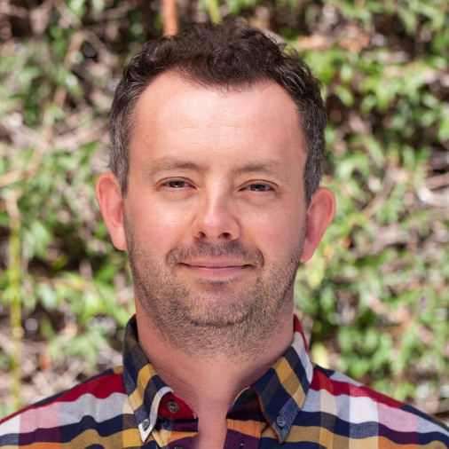
As Head of Television for Bad Robot, Ben Stephenson oversees all aspects of the company’s TV development slate. Bad Robot’s television projects include the hit series Westworld on HBO; anthology series Castle Rock on Hulu; Lovecraft Country on HBO; Demimonde, written by J.J. Abrams, on HBO; and Little Voice and Lisey’s Story both set up at Apple.

Prior to joining Bad Robot in 2015, Stephenson led BBC Drama, where he ordered and oversaw more than 450 hours of drama a year on the Brit pubcaster, including Sherlock, Call The Midwife, Luther, Happy Valley, The Missing and Wolf Hall. He also helped reinvigorate BBC Two drama with such series as Peaky Blinders, The Fall and The Honourable Woman.

In 2015, Stephenson received the Royal Television Society special recognition Judges’ Award for his extraordinary contribution to the genre

